What was your favourite part of the work you did?

What would you like to learn more about?

**List and describe** three key words you learned during this unit of work:

1)

2)

3)

How do you **feel** about your Twisted Vista creations now we have completed this unit of work?

Evaluation

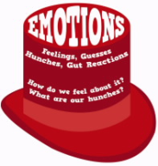

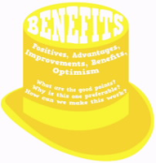



Did you have any problems with working as a group or as an individual?

What did you find difficult?

If you had more time to work on  **ideas** would you have worked on?

List at least three improvements that you could make to your work:

1)

2)

3)

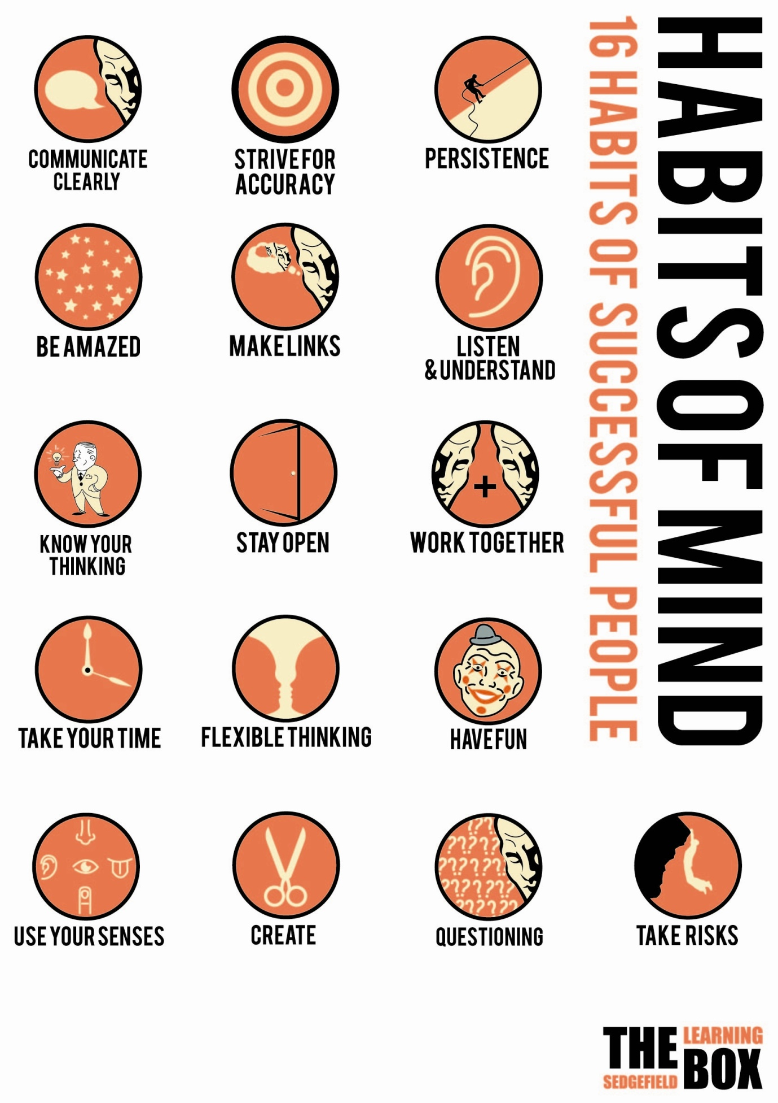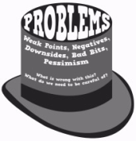 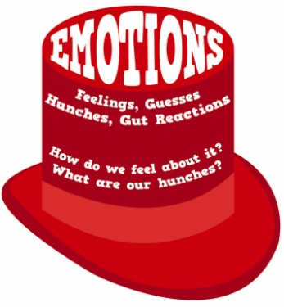

**Have a questioning attitude about your work.**

**What did I do well?**

**What can I do to improve?**

Ideas: